**Pseudocode**

**1. Calculate S = (A + B + C) / Y**

Step 1: start

Step 2: read values of A, B, C

Step 3: sum <- A + B + C

Step 4: S <- sum / Y

Step 5: Write value of S

Step 6: display value of S

Step 7: stop

**2. Convert from Celsius to Fahrenheit (F = (C x 9 / 5) + 32)**

Step 1: start

Step 2: input C

Step 3: F <- (C x 9/5) + 32

Step 4: Write value of F

Step 5: display value of F

Step 6: stop

**3. Calculate the volume of sphere (4 / 3 x x r3)**

Step 1: start

Step 2: input r

Step 3: calculate 4 / 3 x x r3

Step 4: display volume of sphere

Step 5: stop

**4. Calculate average speed (average speed = distance travelled / time taken)**

Step 1: start

Step 2: read values of distance travelled, time taken

Step 3: average speed <- distance travelled / time taken

Step 4: display average speed

Step 5: stop

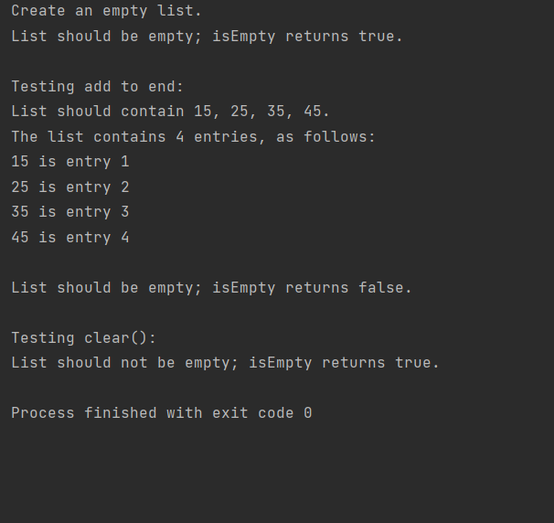ListClient2

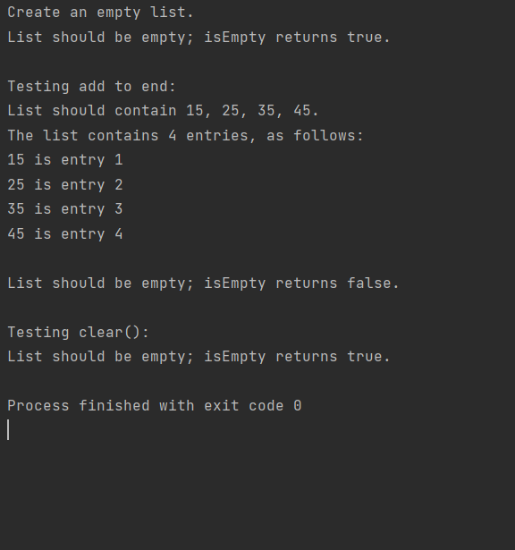ListClient3